**Calculator Free**

**Logarithmic Graphs and Differentiation**

Time: 45 minutes

Total Marks: 45

Your Score: / 45



**Question One: [2, 3, 2 = 7 marks] CF**

Consider the exponential function drawn below.

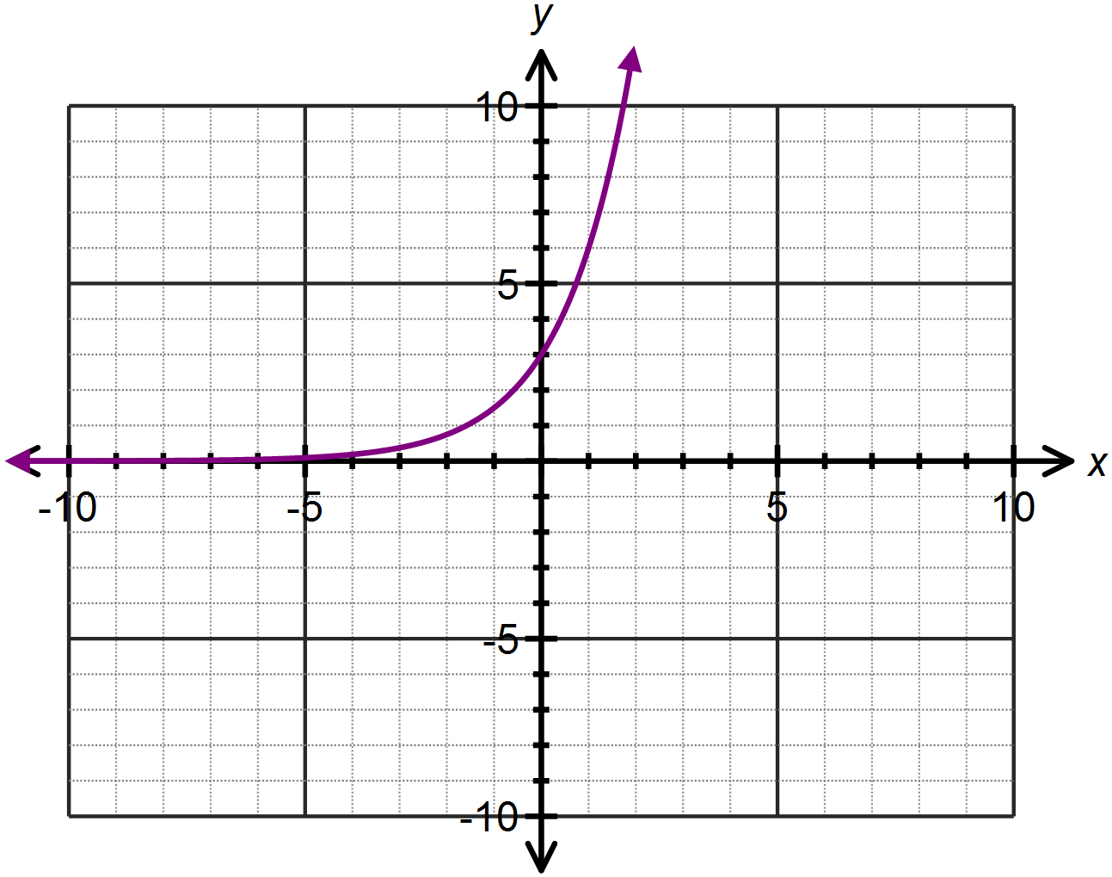

1. State the equation of the exponential function in the form  .
2. Use the exponential graph drawn, and an appropriate mirror line, to draw the logarithmic function which is the inverse of the given exponential function.
3. Hence or otherwise determine the equation of the logarithmic function,  which is the inverse of the given exponential function with the same base.

**Question Two: [2, 3, 3 = 8 marks] CF**

Determine the equation of each of the following graphs drawn below:

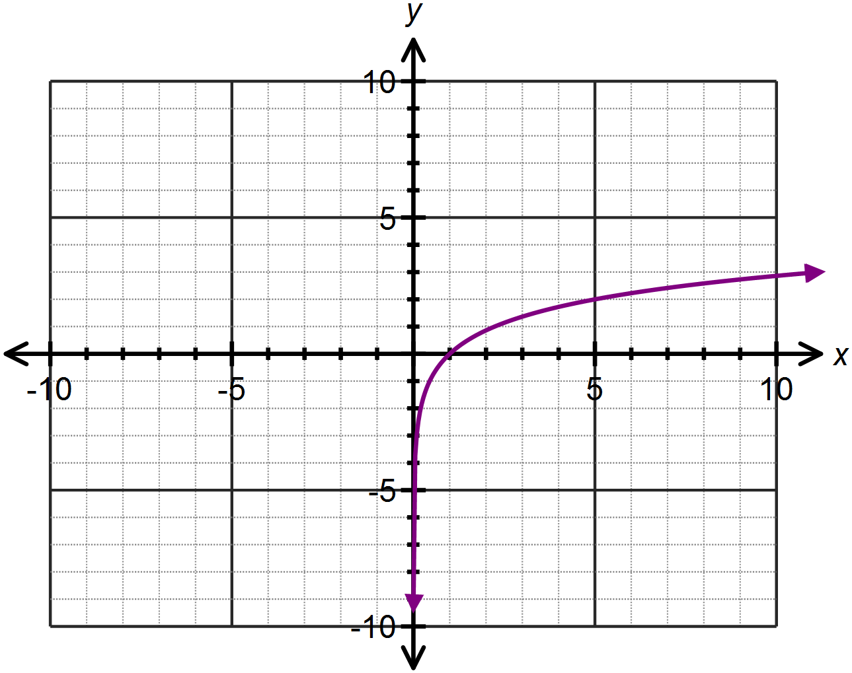

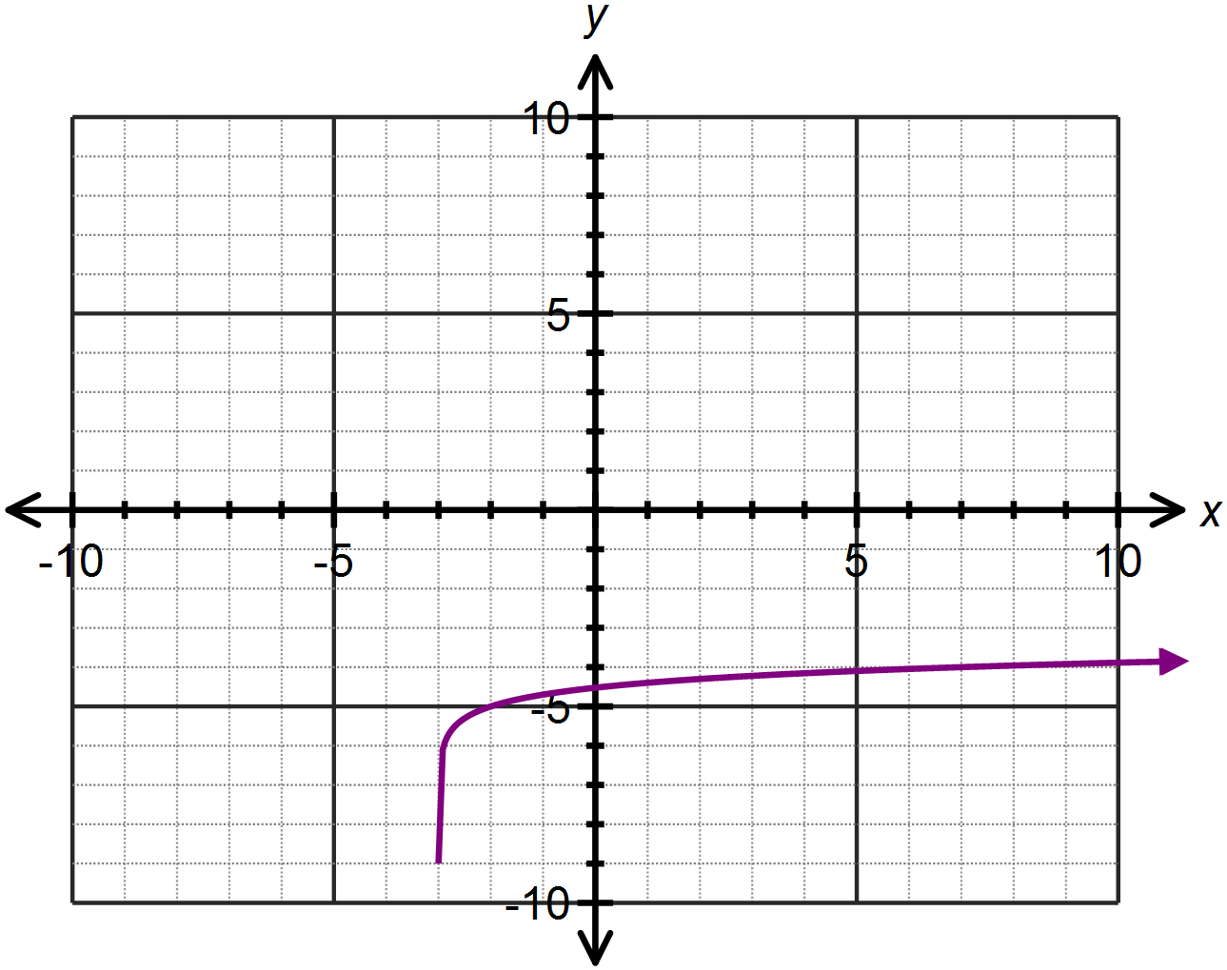

(b)

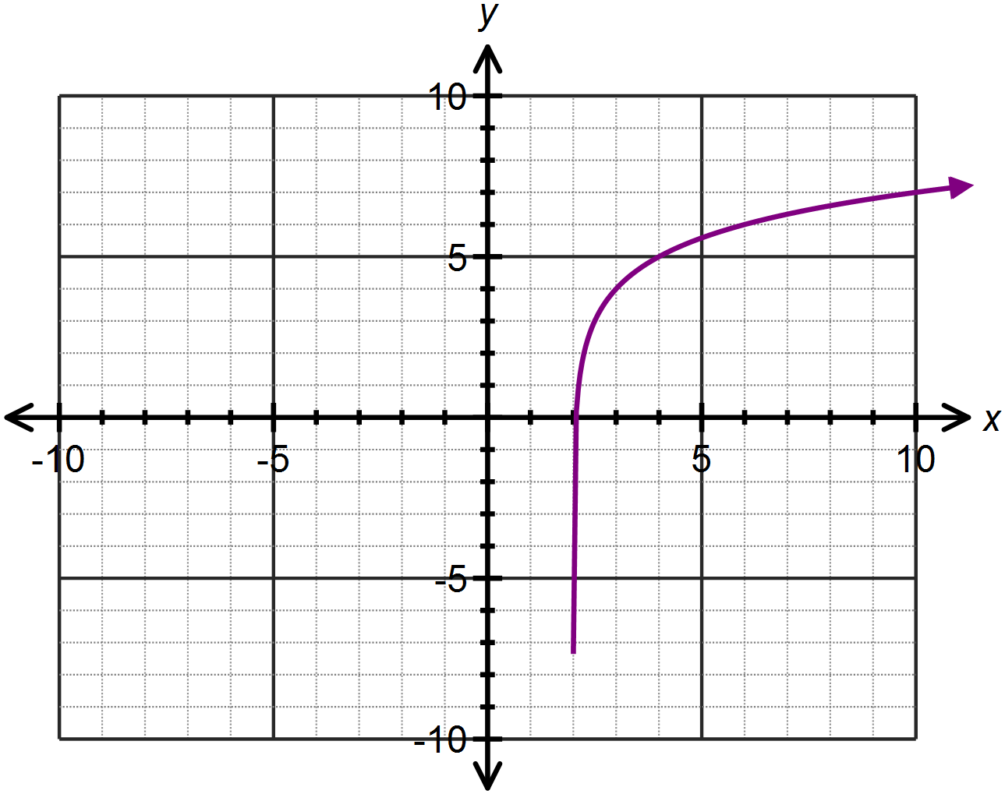(c)

**Question Three: [2, 1, 2 = 5 marks] CF**

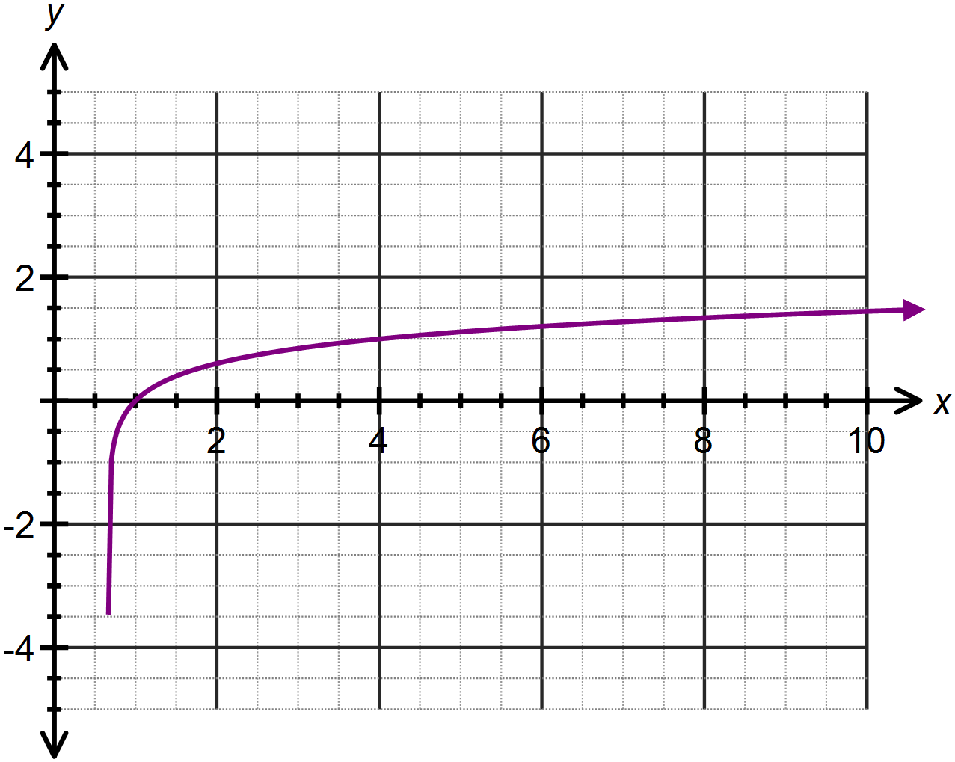The function  is drawn below.

(a) Determine the value of *a.*

(b) Use the graph to approximate the solution to 

(c) Solve  algebraically.

**Question Four: [1, 3, 3, 2, 3, 3 = 15 marks] CF**

Differentiate each of the following with respect to *x*, showing full working:

(a) 

(b) 

(c) 

(d) 

(e) 

(f) 

**Question Five: [5, 5 = 10 marks] CF**

(a) Determine the coordinates of the point(s) where the curve  has a gradient of 2.

(b) Determine the equation of the tangent to the curve  at the point where  . Leave your answers as exact simplified values.

**SOLUTIONS**

**Calculator Free**

**Logarithmic Graphs and Differentiation**

Time: 45 minutes

Total Marks: 45

Your Score: / 45



**Question One: [2, 3, 2 = 7 marks] CF**

Consider the exponential function drawn below.



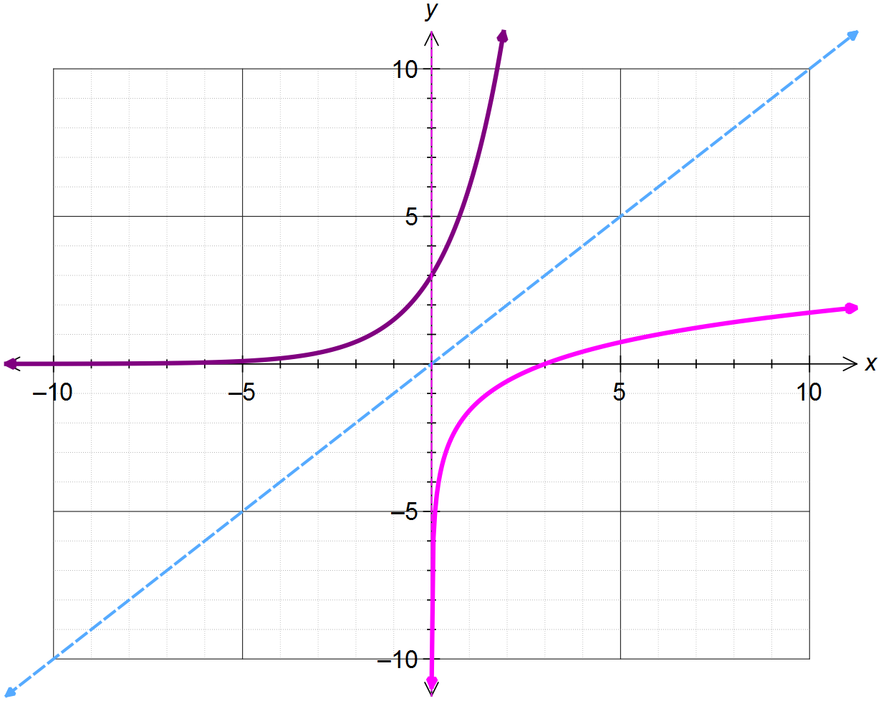





1. State the equation of the exponential function in the form  .



1. Use the exponential graph drawn, and an appropriate mirror line, to draw the logarithmic function which is the inverse of the given exponential function.
2. Hence or otherwise determine the equation of the logarithmic function, which is the inverse of the given exponential function with the same base.



**Question Two: [2, 3, 3 = 8 marks] CF**

Determine the equation of each of the following graphs drawn below:

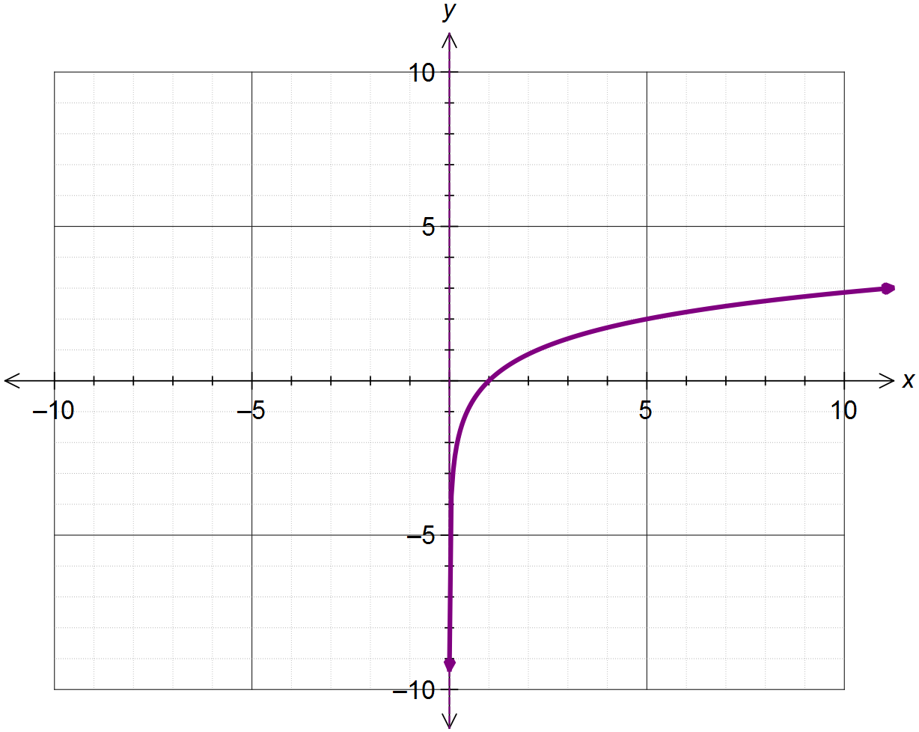







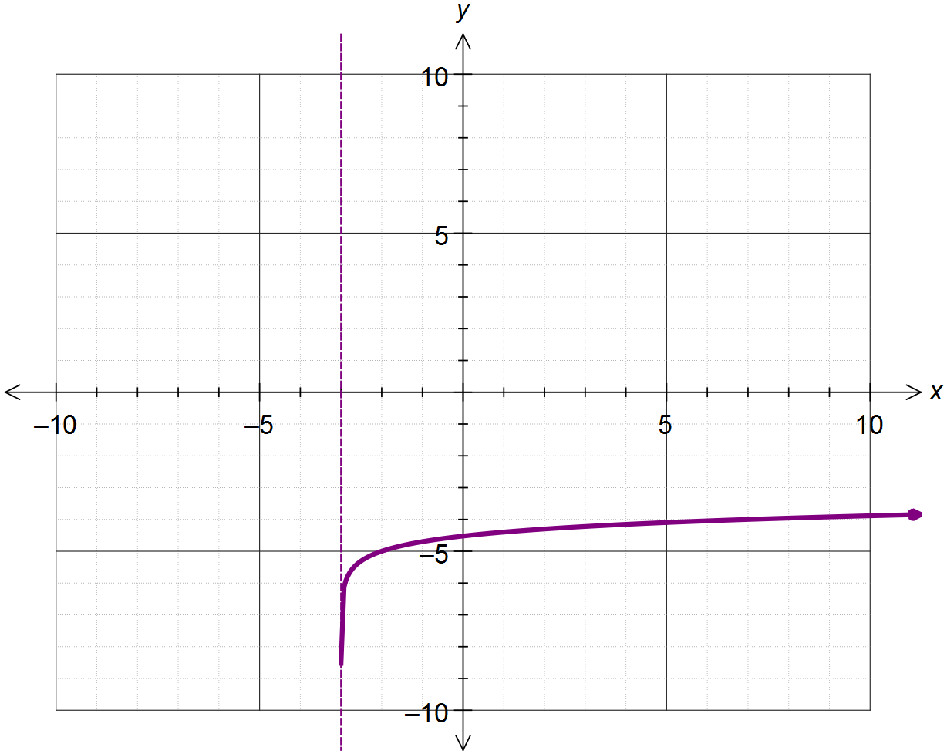

(b)







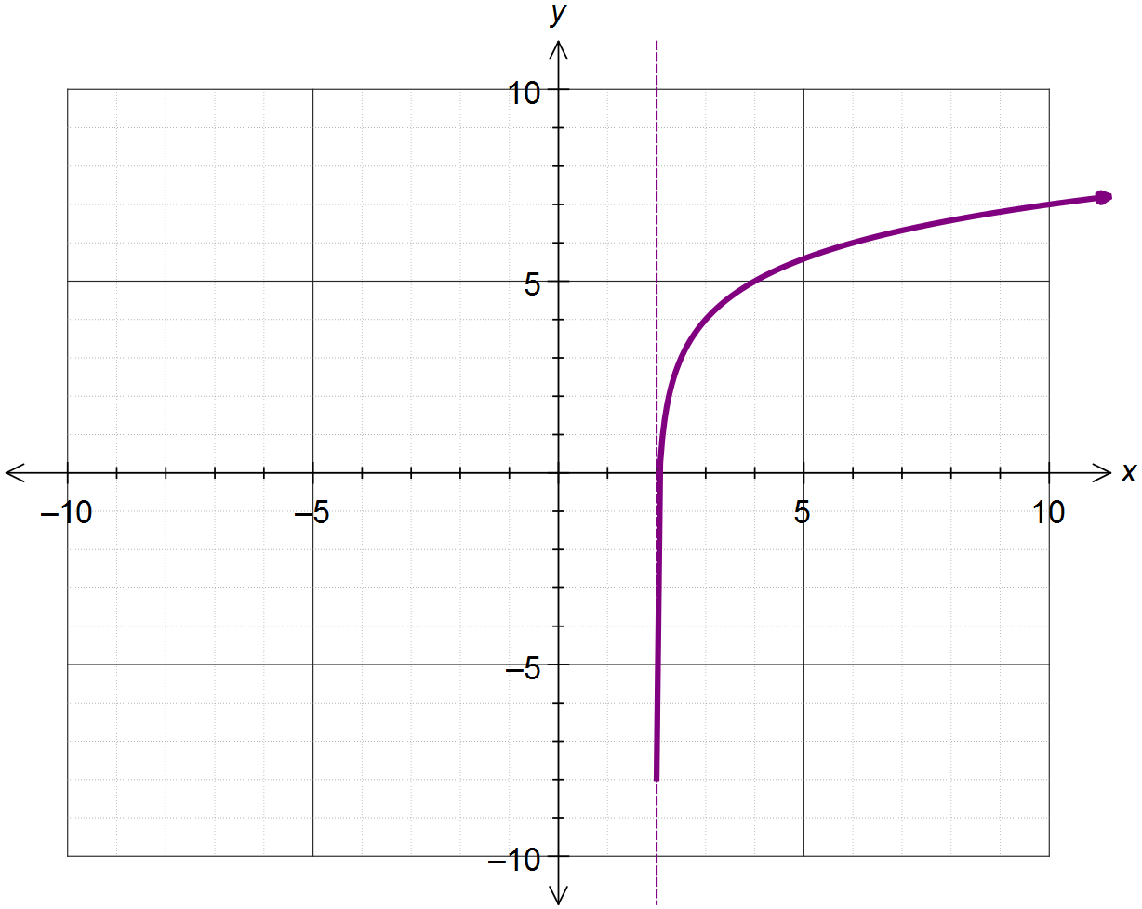(c)





**Question Three: [2, 1, 2 = 5 marks] CF**

****The function  is drawn below.

(a) Determine the value of *a.*



(b) Use the graph to approximate the solution to 



(c) Solve  algebraically.



**Question Four: [1, 3, 3, 2, 3, 3 = 15 marks] CF**

Differentiate each of the following with respect to *x*, showing full working:

(a) 

 

(b) 



 

(c) 

 



(d) 



 

(e) 

 

(f) 



 

**Question Five: [5, 5 = 10 marks] CF**

(a) Determine the coordinates of the point(s) where the curve  has a gradient of 2.



 

(b) Determine the equation of the tangent to the curve  at the point where  . Leave your answers as exact simplified values.

 